
Alexander Kent studied Cartography and Geography under the direction of Roger Anson at Oxford Brookes University, followed by an MPhil in GIS and Remote Sensing at the University of Cambridge. He returned to Oxford Brookes to lecture in these subjects and also became a cartographic consultant on a variety of projects, from an 'Atlas of the Social and Intellectual History of Islam' at the Oxford Centre for Islamic Studies to an 'Interactive Atlas of World History' for schoolchildren. A keen interest in topographic maps and landscapes cumulated in his PhD thesis ("An Analysis of the Cartographic Language of European State Topographic Maps: Aesthetics, Style, and Identity") at Canterbury Christ Church University under the supervision of Peter Vujakovic. Alex is currently Assistant Editor of The Cartographic Journal.

AN ANALYSIS OF STYLISTIC DIVERSITY IN EUROPEAN STATE 1:50 000 TOPOGRAPHIC MAPS
Alexander Kent
Canterbury Christ Church University, UK
E-mail: alexanderjameskent@yahoo.co.uk

1. INTRODUCTION
Given their unique status and prominence among cartographic products, there is a surprising lack of empirical research into how official topographic maps differ between countries. In addition to the inconsistency surrounding the definition of topographic maps and the scales they use (Larsgaard, 1984: 3-8), there is also doubt concerning the degree to which topographic maps are said to exhibit variation in their design. The use of cartographic conventions regarding colour, e.g., blue for water, brown for contours, green for vegetation, and black for ‘cultural’ features, would indeed create a similar appearance among maps produced by different countries, and, if variations exist in the surface of the earth, it follows that they will exist on topographic maps. But diversity in the appearance of topographic maps cannot result purely from variations in the land because maps of the same geographical area covered by two different mapping organizations do vary in appearance, as in the case of the Alps, for example. It is choice that affects the selection of features and design of individual symbols, which in turn affect the map holistically as a symbol of the landscape.
This report describes an investigation of stylistic diversity using paper 1:50 000 topographic maps produced by national mapping organizations (NMOs) from twenty different European countries. A typology was constructed to provide a suitable means with which to compare the style of topographic maps, which involved the creation of a classification system for sorting each distinct graphical symbol into mutually exclusive categories. The relative proportions of symbols within each category were then compared, along with major elements of their appearance, such as colour, ‘white’ space, visual hierarchy, and lettering. This report outlines the extent to which similar styles of cartography were exhibited in the sample maps.

2. DEFINING CARTOGRAPHIC STYLE
The use of the word ‘style’ is dependent upon the recognition of certain, defined similarities within a group and also upon the recognition of differences outside the group. In cartography, style seems to be used for describing a certain form of expression, leaning towards the general as opposed to the specific results of symbolization. While style has also been used to distinguish between classes of maps, i.e., topographic sheets, atlas maps and school maps (Genthe, 1913: 33), this seems to be less widespread. As in the realm of publishing, maps often exhibit a ‘house style’ that is demonstrated through the particular use of colour, typography, and symbols, for example.
John Keates was especially keen to recognize the existence of style and asserted that ‘many modern topographic map series fall into a stylistic group, in the sense that they are based on an accepted and effective method of design and representation. What is called the “Swiss manner” is probably the best example’ (ibid.: 252). The idea that individual countries might produce topographic maps in a particular style has a great deal of significance because it suggests that the landscape may be symbolized in a way that is definable and recognizable as belonging to a country. Conversely, the existence of a supranational style was also suggested by Keates:

Virtually all medium-scale topographic map series are based on a “classical” style which evolved with the introduction of lithographic printing. This made possible the use of different hues to represent and contrast the major feature categories. In its simple form this is based on black planimetry, blue water, brown contours and green vegetation (Keates, 1996: 256).

Basing the notion of style on the use of colour makes a link between the appearance of a map and cartographic production capabilities and limits. It also defines a particular manner, a convention, which has been derived from certain schema (rules for structuring the unity of experience) over time; the use of blue for water and green for vegetation, for example. But with the acknowledgment of a basic style also comes the possibility of recognising departures from it, leading to a notion of distinctiveness. Knowles and Stowe (1982: 26, 56) referred to the style of Swedish 1:100 000 maps as ‘legible and aesthetically satisfying’ and that of the Belgian 1:50 000 series maps as ‘very bold’. Nicholson (2004: 194) went so far as to detect Art Nouveau, Art Deco, and ‘the wilder shores of Italian Futurism’ in early twentieth century motoring maps, but these observations were based on cover designs, which, by their nature, do not fall under the same design constraints as the map itself.
The cartographic style of a national series of topographic maps is derived from how the landscape is symbolized, in terms of both content and appearance. Through the processes of abstraction and generalization, its character is suggested through a particular selection of features and their expression through the creation of symbols according to the customary use of the graphic variables available. In addition, the coordinated relative emphasis of map symbols (reflecting the interests of the NMO and with them the perceived needs of society) conveys an apparent hierarchy of features and suggests the character of the national landscape on a more holistic level. Moreover, successful topographic mapping requires the aesthetic qualities of the national landscape to be incorporated in the process of symbolization.
Topographic maps retain a particular choice of features which appears to be the most useful, i.e., having the highest number of potential functions (or the highest significance), to the greatest number of users.
They are consequently rich in complexity and exhibit the application of skill, involving many different individuals and meeting several levels of approval, so the evolution of style in topographic maps is relatively slow. Changes require the collective judgment of many involved in the design process within the native NMO and it would therefore seem that in major departures from the established style, the input of individuals is hard to trace. (An analogy may be drawn with the Gothic cathedrals of Europe.)
In the cartography of topographic maps, style therefore has more to do with the general quality of expression than the introduction of innovative ways of visualising the landscape that may be introduced by an individual. But there are some rare exceptions, as in the case of Eduard Imhof and his contribution to Swiss topographical mapping. The development of his own style of mountain relief cartography in the 1920s (Dorling and Fairbairn, 1997: 112) and subsequent role in the creation of what Keates (1996: 252) refers to as the ‘Swiss manner’ or what Collier et al. (2003: 20) call the ‘Swiss style’, suggests one instance. But if methods of cartographic production, at least, allow for radically different styles, it is plausible to suggest that these could provide the technical basis necessary for the evolution of topographic maps.

3. METHODOLOGY
The investigation involved the construction of a typology of cartographic style, through which the symbologies produced by NMOs across Europe could be compared and analysed. As all topographic maps involved in this typology were those currently produced by European NMOs, these became the smallest entities with which particular styles might be associated. While it may therefore seem plausible to define these as ‘national styles’, such a definition would require a thorough investigation into the heritage and evolution of cartographic symbology. The aim therefore, was to analyse the symbology of current topographic maps in order to discover whether wider comparisons were possible and consider how the resulting ‘styles’ may be understood – perhaps as ‘dialects’ of the cartographic language of
1:50 000 topographic maps.
Of the few studies that offer interpretations of cartographic style, most involve thematic maps, such as public transport maps (e.g., Morrison, 1994; 1996) and cycling and motoring maps (e.g., Nicholson, 2004). Piket (1972), however, was able to differentiate between types of topographic map from a classification of the legend contents by dividing the number of features by the type of feature, raising questions surrounding the design of the maps themselves. Using topographic maps of the same scale (1:25 000) from five different European countries (Belgium, The Netherlands, West Germany and Denmark, Italy, and Switzerland), five types of phenomena were selected – built-up areas, roads, ground cover, orography (relief), and hydrography – to form five ‘range classes’. The number of features represented in the map legend for each was then counted to indicate the variations in selection of feature type, summarizing the overall character of each map. These results led to an identification of a ‘type’ (which could easily be read as ‘style’) of topographic map, based on the treatment of particular features, e.g., the ‘Italian type’, with the accent on relief and a remarkably narrow range for built-up areas and ground cover (Piket, 1972: 276).
Instead of providing an illustrated stylistic comparison between the topographic maps of NMOs at an identical scale the methodology adopted for the ensuing series of studies, by Forrest et al. (1997), Collier et al. (1998a), and Collier et al. (2003) encompassed a range of scales from 1:10 000 to 1:1 000 000 and incorporated both state and privately owned map producers. As scale and type of map maker (i.e., state and commercial) greatly influence factors such as generalization and audience, this method used is unsuitable for examining the similarities and differences between styles of official mapping agencies. Furthermore, despite offering an insight into the different approaches that different map makers adopt to map certain phenomena, their methodology was based on the premise that these were objective phenomena receiving subjective treatment; they posed certain problems of cartographic representation which were overcome in different ways. Different societies map their landscape according to the needs and values of that society and these affect the choices over what to show and how to show it. In other words, not only would the representation of features be different but also the survey of features and the basis for their inclusion or omission. An ideal comparison would therefore need to derive from a situation where different NMOs were involved in mapping the same land at the same time, so that variations in symbology and style would result from the choices made in symbolizing the landscape.
The approach taken in the construction of the typology, therefore, was not to offer a means for describing how the NMOs in Europe encounter similar problems of representation in their symbolization of landscape. Building on Piket’s (1972) approach, it aimed to provide a means for comparing similarity and difference in their symbologies through which a deeper investigation could be built. The typology of European 1:50 000 topographic symbology concentrates on comparing the ‘vocabulary’ used for expressing each national landscape – as shown in the legend (or key) – rather than the local landscapes as shown by individual sheets. It was crucial to ensure as much consistency as possible between samples, because factors such as scale, subject, and relief would greatly influence the degree of symbolization and therefore the choices involved. Moreover, it was also important to bear in mind that it is the symbology that is under investigation, not the local landscape.
The typology incorporates five criteria for comparing symbologies: classification, colour, ‘white’ space, visual hierarchy, and lettering. The backbone of the typology, however, is its system for classifying the map symbologies, whereby each individual and discrete cartographic symbol within a map legend can be sorted into multi-level categories according to the ‘theme’ to which it belongs. The typology therefore allows the measurement of the number of legend symbols used to represent a feature type as a proportion of the total number of symbols used to express the national landscape. The qualifying factor for a symbol to be included relates to the nature of its design: it must comprise of a separate, complete, and unique means of graphic expression within the symbology. As such, each discrete symbol should therefore have the capacity to act as a whole and unified design, intended to denote a particular feature without necessarily involving other symbols. The count avoids all labels (both words and abbreviations) that are not incorporated as part of a cartographic symbol.
In compiling the typology, an a posteriori approach was taken to develop an original range of classes (Fig. 1), which gave more attention to the diversity of features represented on the maps of Europe and allowed a more consistent classification of symbols into mutually exclusive categories. To ensure that the final results of the classification were consistent, the number of classes steadily evolved and symbols were re-sorted. Three levels of classification were adopted to allow various levels of analyses. At the broadest level, the classification distinguishes between Human/Artificial, Natural, and Non-Landscape Features (e.g., grid ticks appearing alongside other features in the legend), to allow a very general assessment of the symbology of the maps. This ensures that ‘physical’ elements of the landscape (e.g., streams and contours) are separated from ‘human’ elements (e.g., canals and triangulation pillars). The most detailed classes in Level III therefore allow even more specific analyses and rely on a closer reading of the feature being symbolized (Table 1). Classification has limitations, however, and the typology aims to be objective in the sense that a classification of the same set of symbologies by the same sequence of methods will produce the same analysis. As with any classification system, there is always room for future development.
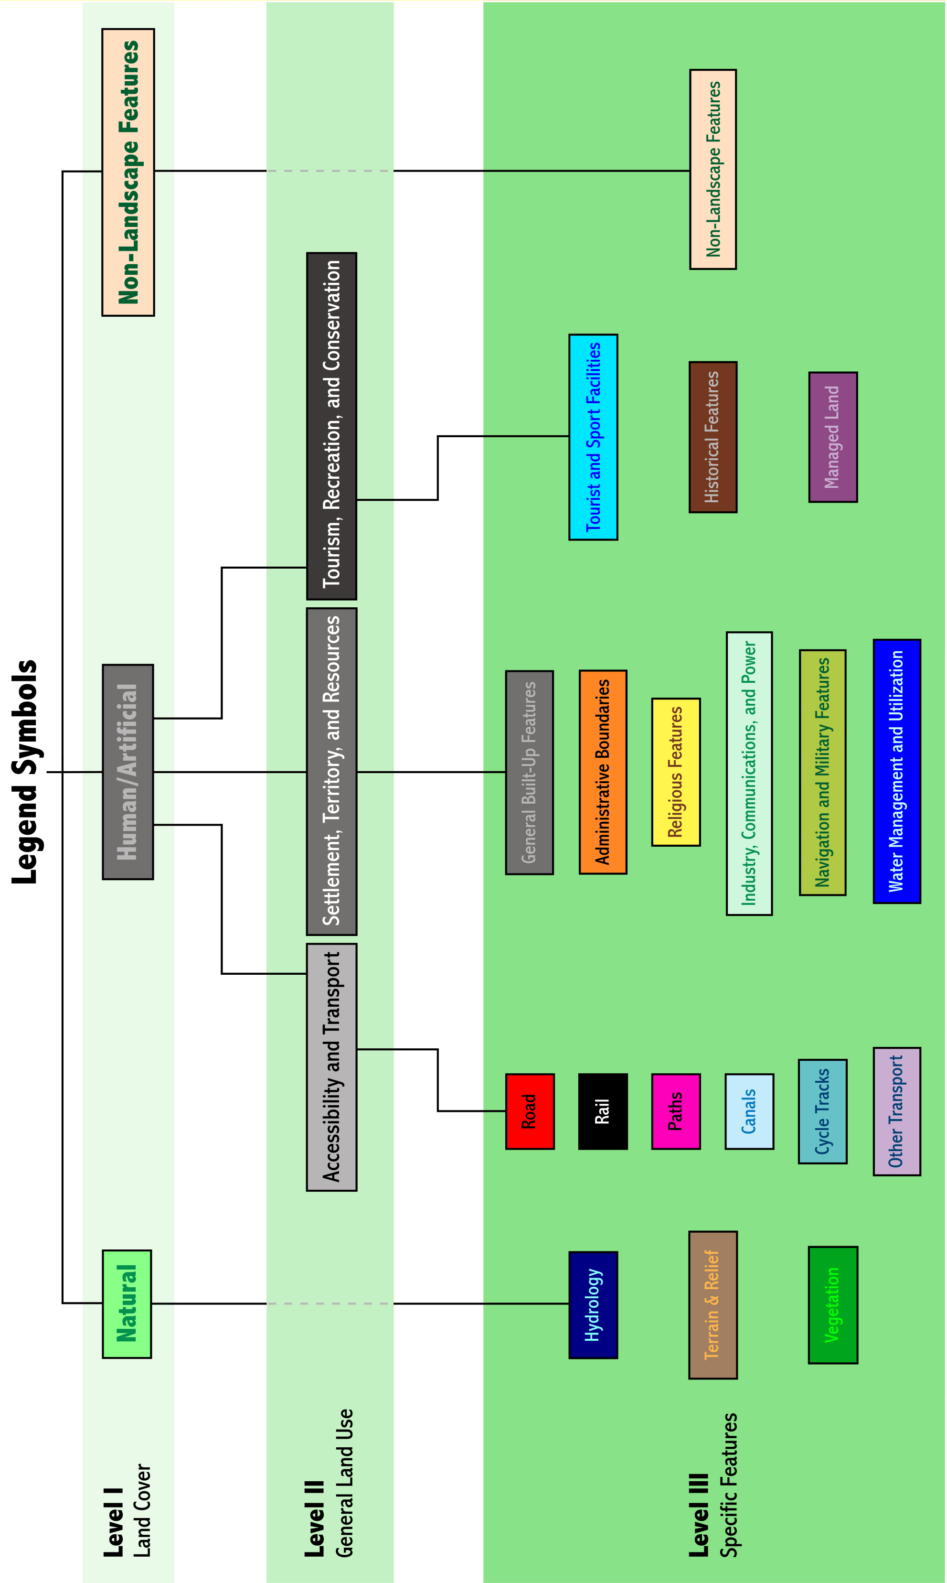
Fig. 1 Typology classification framework

Level Three Class | Examples of Features Symbolized
Road | Motorways, roads, tracks, bus stations, parking, junctions, tree-lined roads, and road tunnels/bridges
Rail | Railways, railway stations, cargo railways, and railway tunnels/bridges
Paths | Footpaths, bridleways, passes, ski-tracks, and footbridges
Canals | Canals, locks, canal beacons, trafficable dykes and aqueducts, and canal water level gauges
Cycle Tracks | Cycle tracks, cycle routes, and cycle bridges
Other Transport | Trams, ferries, ports, docks, airports, and helipads
General Built-Up Features | Residential buildings, schools, hospitals, post-offices, police stations, town halls, farms, towers, fences, and walls
Administrative Boundaries | International, national, district, province, canton, and county boundaries
Religious Features | Cathedrals, monasteries, churches, chapels, and shrines
Industry, Communications,  and Power | Quarries, peat-cuttings and huts, factories, oil/gas stores, radio masts, windmills, watermills, pylons, and power stations
Water Management and Utilization | Reservoirs, fountains, dams, dykes, levees, irrigation canals, weirs, water towers, groynes, sluices, and sewage facilities
Navigation and Military Features | Triangulation pillars, cairns, isolated objects as reference points, beacons, lighthouses, shipwrecks, and military camps
Tourist and Sport Facilities | Hotels, campsites, golf courses, ski-lifts, cable-cars, sports centres, and football pitches
Historical Features | Castles, ruins, ancient earthworks, burial mounds, and monuments
Managed Land | National parks, nature reserves, cemeteries, gardens, and parkland
Hydrology | Bodies of water, submerged rocks, rivers, streams, springs, currents, and bathymetric depths
Terrain and Relief | Contours, spot heights, escarpments, natural escarpments, rocks, scree, sand, cliffs, caves, glaciers, and snowfields
Vegetation | Woods, forests, grassland, open land, shrubland, heathland, meadows, hedges, orchards, vineyards, and arable land
Non-Landscape Features | Grid intersections
Table 1 Examples of legend symbols classified at the Level III classification

The scale of 1:50 000 was selected for numerous reasons. Firstly, this scale provides some equilibrium between representation and abstraction, being small enough to allow an appreciation of its rendition of the landscape but sufficiently large to render distortions caused by the map projection to have a minimal effect on the representation of features. Secondly, different scales also suit different purposes and here, the choice of 1:50 000 also represents a balance. Scales larger than 1:10 000 for example (which are often referred to as plans), usually relate to cadastral or other land administration issues such as utilities management and with smaller scales (such as 1:100 000), the purpose of the map leans towards navigation. Thirdly, the balance of purposes that the 1:50 000 scale is intended to serve means that the resulting maps are perhaps the most ‘general purpose’ of general purpose maps and consequently, topographic maps at this scale are designed for a wider market, serving more users than other scales. All European countries have been mapped at 1:50 000, with a greater number of native NMOs producing dedicated mapping at 1:50 000 than at any other scale. Moreover, as this scale is employed in topographic map series worldwide, another reason for this choice is that it offers scope for the comparison of map series from further afield.
Another important decision concerned which format – paper, digital, or both – should be included in the typology. For centuries, paper has formed the traditional medium for the production of topographic maps. As finite creations, paper maps are limited in the quantity of detail they can show and the consequences of selective choice – and hierarchies between different types of feature – remain a product of the values of the institution involved in the map’s creation. So to achieve as much consistency as possible, only current, standard, official, civilian edition 1:50 000 paper topographic maps were included in the typology; all of which will have been designed according to pre-determined specifications and for general release.
The selection of sample sheets was initiated by identifying areas of approximately similar topography and urban cover using a small-scale topographic map of Europe and subsequently chosen from country indexes provided in Parry and Perkins (2000) and the relevant NMO websites. Requests for maps meeting the criteria above were sent to 38 European NMOs, using contact information supplied in Parry and Perkins (2000), EuroGeographics (2003), and NMO websites, with the aim of including one sample map from as many countries as possible from within and outside the European Union. Although most countries in Europe are represented in some way, a few NMOs were not contacted as it was discovered through various sources (i.e., Böhme, 1989; 1991; 1993; Parry and Perkins, 2000; and EuroGeographics, 2003) that current official 1:50 000 maps available for civilian use were unlikely to be acquired. This included the Republika Geodetska Uprava of the Former Yugoslav Republic of Macedonia, where only military editions of 1:50 000 maps exist. Northern Ireland, which has its own mapping agency, Ordnance Survey of Northern Ireland (OSNI), was not included because it does not share the same level of responsibility as other NMOs. Although in Germany the 16 Länder are each responsible for producing their own topographic maps, these still come under the centralized jurisdiction of the Bundesamt für Kartographie und Geodasie and so a sample from Nordrhein-Westfalen was still valid for the purposes of this study. The limited success of obtaining maps perhaps serves to highlight the unavailability of certain topographic map series outside their countries of origin (Map 1). The low level of responses from the former Soviet satellite countries and former republics of the Soviet Union is distinctive, although a similar result was experienced in the survey of map production and publication of these countries by Collier et al. (1996; 1998b).
As it was beyond the scope of the study to record and investigate the colour of every map symbol, a series of representative groups of symbols were examined. These consisted of point, line, and area features, which together constitute the majority of the map surface:

Land Use: General Built-up Features, Roads, Railways, and Arable and/or Pastoral Land;
Land Cover: Forests, Rivers, Rocks/Scree, and Vegetation; and
Other: Tourist Point Symbols, Borders, and any other features.

As colour is such a powerful variable, it is important for this aspect of the typology to be flexible and accommodate symbols that may not fall easily into the other, more broadly-defined categories.
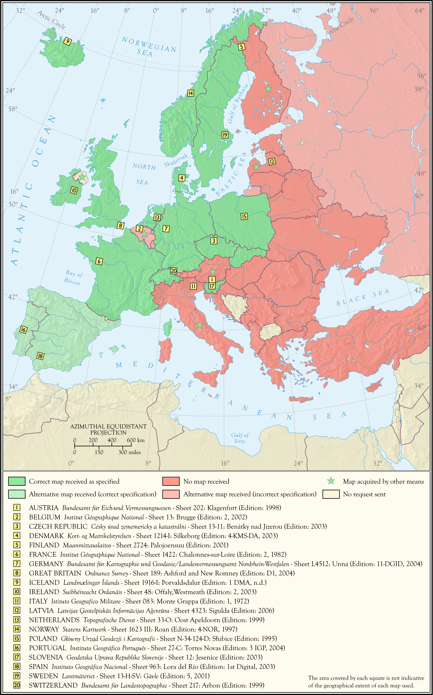
Map 1 Responses to map requests by country with details of map sheets involved in the typology
‘White’ space is the base colour of a map, which may not necessarily be white, and is not explained in the legend, but which, by its nature, forms the ultimate ‘ground’ and can influence style. ‘White’ space retains meaning through its power of suggestion and assumption and may use other colours to suggest the omnipresence of a certain feature or characteristic of the landscape. Pure ‘white’ space offers no definitions and lets the reader assume the basic nature of the landscape, but its ‘colour’ (or pattern) may suggest the existence of a particular landscape and can help to construct this in the reader’s mind.
Although Robinson et al. (1995: 327) assert that a strong visual layering is to be avoided on general reference maps, given that paper topographic maps are limited in their capacity to treat all features equally, the selective inclusion and omission of features and their subsequent emphasis can suggest levels of
importance through the use of variables such as size and colour. Larger, darker symbols appear to be closer and more significant than smaller, lighter ones. The visual hierarchy was judged from the characteristics of symbols falling into the same classes of features as above. The top three feature types considered to be the most prominent on the legend and reinforced on the map (and thus the highest in the visual hierarchy) were recorded in order in the typology. A comparison of these features between maps may therefore also give an idea of the relative importance of these features between the different countries.
The term ‘lettering’ incorporates the various aspects of labelling on maps, including typographic design and the placement of text. The use of varying sizes and styles of label can also suggest a visual hierarchy, and, in conjunction with symbol design, is often used to indicate the relative importance of settlements. In this study, typographic design was classified according to the following criteria, which allow for a flexible and holistic appreciation of typographic design and regards the differences as a continuum based on their general appearance (Fig. 2).

( Mechanical Technological Progressive Official Rational Impersonal )
Score ‘Objective’
1 Sans-serif Plain (e.g., Gill Sans – plain)
2 Sans-serif Italic (e.g., Gill Sans – italic)
3 Serif Plain (e.g., Times New Roman – plain)
4 Serif Italic (e.g., Times New Roman – italic)
5 Handwritten (e.g., Certificate)
‘Subjective’
( Organic Rustic Antique Cultural Emotional Personal )
Fig. 2 A continuum for classifying type styles on topographic maps

This range was therefore applied to describe five different feature labels in the typology: settlements, relief features, rivers, and the legend explanation text itself. By allocating a score to each of these styles ranging from one to five, it was also possible to generate a total value, which provides a quantitative comparison of the overall typographic style of the map in relation to the continuum above and suggests the degree of deviation from a uniform appearance and the ‘objective’ connotations that may be implied through their use.
The sample of countries used in the study therefore exhibits considerable variation in terms of population size, land area, location, climate, economic and industrial development, political heritage, and culture, and, within the constraints suggested by scale, the choices made regarding the five elements together have the greatest influence over the symbolization of features (and thus the appearance of the map as a whole). As all map sheets involved in the typology are printed using at least four colours, a substantial range of expression was available to reflect this variation, granting NMOs the potential to demonstrate commonality or uniqueness through cartographic design.

4. ANALYSING STYLISTIC DIVERSITY IN EUROPEAN 1:50 000 STATE TOPOGRAPHIC MAPS
The first step in the analysis was to compare the total numbers of discrete symbols used in the symbolization of landscape, as determined from the map legends (Table 2). If higher symbol counts signify more extensive ‘vocabularies’, the resulting maps will be more comprehensive in their symbolization of landscape. With a standard deviation of 36.78 from a mean of 119.40 for the sample, the degree of variation in the total number of symbols that NMOs use to express the landscape is not small. Slovenian topographic maps use 57 more symbols than the country using the next highest total, Italy, which itself uses more than double the count of the Irish legend symbology.

Country (Rank) | Symbology Total | Country (Rank) | Symbology Total
Slovenia (1) | 218 | Belgium (11) | 117
Italy (2) | 161 | France (12) | 109
The Netherlands (3) | 159 | Germany (13) | 108
Switzerland (4) | 155 | Spain (14) | 100
Great Britain (5) | 149 | Finland (15) | 91
Poland (6) | 132 | Norway (16) | 86
Latvia (7) | 131 | Denmark (17) | 80
Sweden (8) | 125 | Czech Republic (18) | 76
Austria (9) | 124 | Iceland (19) | 74
Portugal (10) | 120 | Ireland (20) | 73

Table 2 Total number of legend symbols in 1:50 000 topographic maps symbologies ranked by country

As a national framework of spatial information, state topographic maps are produced for a variety of purposes. But it was clear that NMOs with a legacy of military impetus generally adopt a greater number of discrete symbols for their civilian topographic maps than others. Moreover, members of the EU or NATO tend to use a more extensive 1:50 000 symbology. The geographical distribution of these counts indicates a degree of regional bias, with many neighbouring countries using similar amounts of symbols, i.e., Slovenia and Italy; France, Belgium, and Germany; Sweden, Poland, and Latvia; and Denmark and Norway. Additionally, countries located towards the geographical fringes of the sample tend to utilize fewer symbols, especially Iceland, Ireland, and the Czech Republic (and to a lesser extent Denmark, Finland, Norway, and Spain). The distribution pattern also reveals two small pockets where the most extensive cartographic vocabulary is employed; one comprising the Netherlands and Great Britain, and the other Switzerland, Italy, and Slovenia. As these countries are served by mapping organizations founded in the eighteenth and nineteenth centuries and are among the oldest in Europe, it seems plausible to suggest that their symbologies have grown to incorporate more inter-textual elements resulting from a longer history of cultural and cartographic exchange.
As explained above, the main component of the typology is the classification of discrete cartographic symbols from each printed topographic map legend symbology into three hierarchical levels. Star plots provide a visually effective means of comparing the characters of country symbologies, especially at the most detailed level of symbol classification (Figs. 3 and 4) and it is possible to discern three broad categories. These are: topographic ranges that are reasonably balanced (e.g., Slovenia); those with few feature types dominating (e.g., Iceland); and those with one feature type dominating (e.g., Great Britain). Moreover, a visual comparison of these star plots suggests that some countries are more ‘articulate’ than others in describing particular features, as they use more symbols for these classes, such as ‘Road’. Of more relevance, however, is that plots of some pairs of countries have similar shapes (e.g., Great Britain and Ireland; Finland and Iceland; Germany and Denmark; and Latvia and Slovenia).

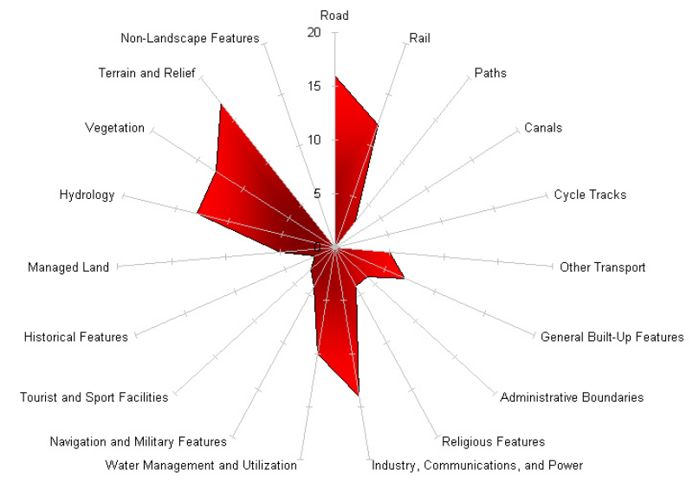
Fig. 3 Star plot indicating the Level III symbol count for Poland

Although it is useful to compare symbologies according to the number of symbols counted within each class, what is likely to offer more insight in exploring stylistic similarities and differences is a comparison of how a feature has been treated as a proportion of the entire symbol set. In order to analyse and classify the various symbologies according to the relative proportions of these feature types it was necessary to introduce a more rigorous method. Cluster analysis was performed in order to classify the symbologies by dividing them into groups according to similarities in their percentage values for each class. The technique applied here was agglomerative (or hierarchical) cluster analysis, which explores the data to determine the quantity of groups.
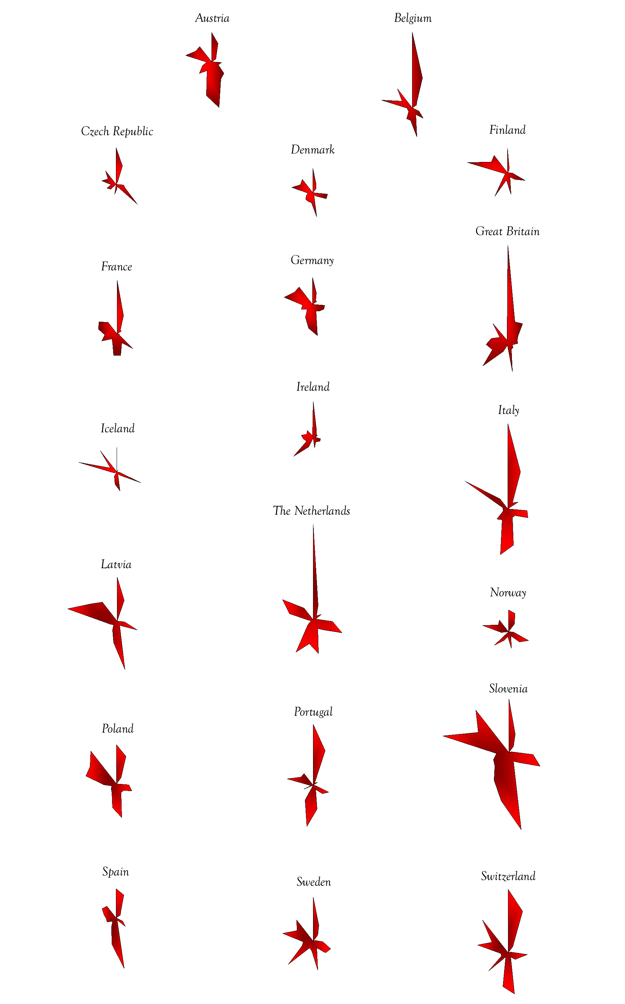
Fig. 4 Star plots of each symbology based on the symbol counts for each Level III feature and plotted on identical axes (surface area of each plot indicates total symbology size)
The method starts with n clusters, where n is the number of objects (the symbologies in this case), and proceeds by merging the two which are most similar so that n – 1 clusters remain. The closest objects continue to fuse at each stage until only one cluster is left, fused at a level that encompasses all the other clusters, and thus objects, which gives rise to its hierarchical structure. As each fusion remains in place throughout the process, the stage at which each cluster is merged is especially relevant as it marks the degree of efficiency in making the fusion. Those merging later in the process require more ‘effort’ to fuse together, and, for this particular case, would therefore indicate symbologies that were stylistically less similar than those fused at earlier stages.
In an agglomerative dendrogram (Fig. 5), the horizontal scale indicates the distance between the groups clustered together, so that the fusions made first (and most efficiently) appear nearest to this axis. Countries with proportions of symbols that are deemed to be most similar are joined first and these links appear nearer to the left, with a distance closer to zero. Subsequent fusions between clusters of countries therefore occur further along the horizontal scale, to the right of the dendrogram.

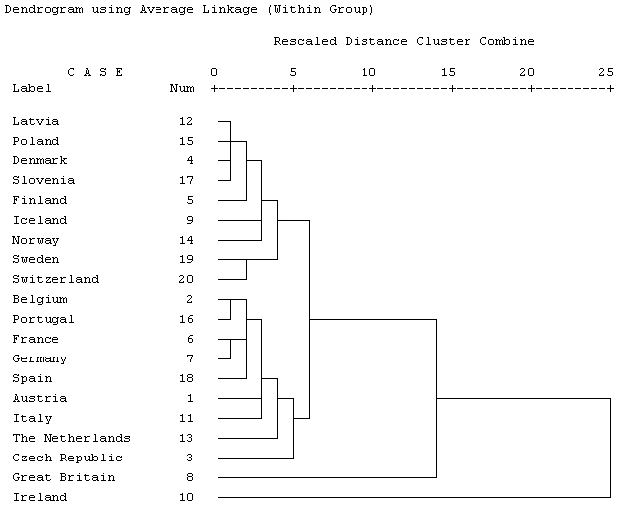
Fig. 5 Dendrogram from cluster analysis using the within-groups linkage method, based on percentage values for Level III (data standardization: mean value for variables = 1)

From the results of the cluster analysis, it was possible to divide the countries into seven general groups using the Level I and Level II classification data and three groups from the Level III data. Map 2 summarizes these groupings. It is clear that the symbologies comprising each of the groups above demonstrate a particular balance of feature types. In terms of the Level III classification, for example, Group 1 is characterized by the smallest overall symbol count and the most balanced topographic range, using similar proportions of symbols for the Road and Industry, Communications, and Power categories, and with a relatively high number of symbols allocated to Hydrology, General Built-Up Features, and Terrain and Relief. Group 2 countries allocate a relatively high proportion of symbols to the Industry, Communications, and Power and Water Management and Utilization classes, and, in contrast to Group 1, Vegetation would seem to be more

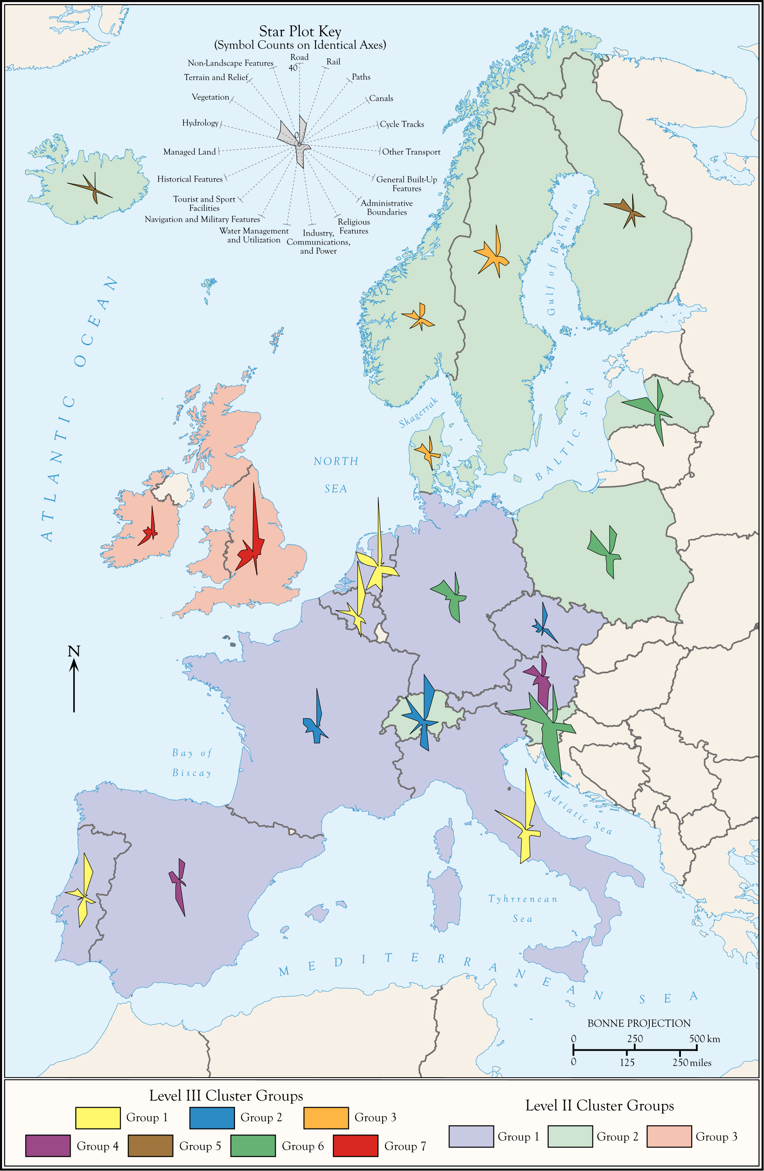
Map 7.4 Geographical distribution of cluster groups derived from all classification data

important than both Hydrology and Terrain and Relief. Group 3 countries, however, are dominated by symbols belonging to the Road class, but with a relatively high proportion dedicated to Tourism and Sport Facilities, Historical Features, Managed Land, and Paths. This group also has the least extensive selection of Rail symbols. The deficiency of symbols from other classes (such as Industry, Communications, and Power and Water Management and Utilization) would suggest that the topographic maps of Group 3 present a landscape to be treated as a commodity for leisure and recreation rather than resources or territory, where users can escape to and access a sense of wilderness. In addition, Group 1 consists of mostly Non-EU 15 countries and those towards the periphery of countries with lower total symbol counts. Group 2 is made up almost exclusively of contiguous EU 15 countries and Group 3 is made up of the two (EU 15) countries representing the British Isles. As style is a case of how a feature is depicted in addition to whether or not it is depicted, an analysis of the qualitative elements of the typology will determine whether the similarity between countries in the groups above extends to this aspect of the portrayal of their landscape.
Advances in printing technology and the desire of national mapping agencies to exploit these has meant that the ‘classical style’ is no longer as widespread as it once was. The most conservative countries seem to be Austria, Portugal, Slovenia, Italy, and France, which closely resemble this early supranational style in their use of colour. Most countries use either black or grey for symbols representing general built-up features. Departures from this scheme usually include some use of red, with countries using red (e.g., Spain), red brown (e.g., Poland), maroon (e.g. Sweden), light pink (e.g., Great Britain), or violet (e.g., Finland). The Alpine countries of France, Germany, Switzerland, Austria, and Italy demonstrate the sole use of black for portraying general built-up features, with the exception of Slovenia. The most complex colour system for general built-up features is that adopted by the Netherlands, with various shades used to discriminate between categories and the innovative use of maroon for high-rise buildings, which, by using a darker figure, appear visibly closer to the user.
Where most country symbologies engage in a radical departure from the ‘classical style’ is through their depiction of roads. Almost gone are the early conventions of using a single colour (such as black or red) to depict this type of feature, which, as determined in the previous section, typically uses more associated symbols than any other feature. As it is likely that many NMOs would perceive road-users to be a key user group for this scale of map, the benefits of using different colours as an aid to classification and navigation are clear and so road symbols exploit the greatest variation in the utilization of colour. Orange, red, yellow, and white are the most common colours for roads, usually in conjunction with a black casing. The colour scheme for the Alpine countries (especially Slovenia, France, and Italy) is similar, as is that between Belgium and the Netherlands, which both use violet for motorways. Great Britain and Ireland are also distinctive in this respect, particularly in their use of cyan for motorways; a colouring system designed to reflect road signage (Harley, 1975: 127). Railways are depicted universally in monochrome and appear either as a solid line or a dashed black line within a black casing. While countries differ in the number of symbols devoted to representing this type of feature and therefore offer varying amounts of detail, the classification of railways is restricted to the variable of line thickness and style (e.g., dashed).
Vegetation is almost universally shown using shades of green, although Finland characteristically uses orange and white area symbols. In most countries, different point symbols are placed over a green background to indicate the type of vegetation. These symbols normally use a darker shade of green, but appear as black in some Alpine countries and also Portugal. Countries do not easily group together regarding the background colour. Although it might be assumed that lime green would perhaps be used by Mediterranean countries and shades of green possessing a higher cyan content by northern European countries (perhaps to mimic the colour of vegetation – coniferous trees for the latter, for example), this is not in fact the case.
Rivers and general contours both tend to be depicted in fairly consistent colours, again drawing parallels with the ‘classical style’, with various forms of cyan in use for the former and orange or brown for the latter. Departures from this include Iceland, which adopts a darker blue for hydrology, and Ireland, which uses grey for contours. Irish maps also exercise a unique hypsometric tinting scheme, where land above 100m appears in a lighter shade of green. The depiction of forests usually follows two main trends, i.e., that of other forms of vegetation, with point symbols depicting the particular type of forest, or simply a plain area symbol. Forests on Finnish maps appear as white, which curiously associates their appearance with orienteering maps, especially given the high number of navigational symbols, but a practical reason for this particular depiction would be that it saves ink.
Of those countries choosing to create a set of point symbols to denote tourist features, most apply black, with the result that tourist symbols exhibit little distinction from other built-up features. This, in itself, points to the ‘classical style’, with all built-up features appearing in black. Sweden uses maroon for its tourist symbols, although this is the same colour as all built-up features in the symbology (with the exception of industrial zones), while Poland uses brown in a similar fashion. However, countries incorporating more tourist symbols within their symbology generally use the most distinctive colours: Great Britain uses cyan symbols, while Denmark and Norway respectively use red and pink. Apart from indicating a consciousness to meet the needs of a specific user group, this use of colour perhaps also reflects the market status of the topographic map within a country. Such topographic maps may be designed to target a sector that may otherwise be bereft of other cartographic products at that scale.
The last category to be considered is that of international boundaries. This is particularly significant because it may provide clues as to how a country considers its national status and possibly how it wishes to express its identity among its neighbours. Most borders at this level follow a similar appearance, i.e., a dashed black line (usually dot-dash-dot) surrounded by a band (or ribbon) in light pink or orange. The countries of Denmark, Iceland, Great Britain, Ireland, Portugal, Spain, and Sweden do not employ this coloured ribbon and this gives the impression of a continuous landscape devoid of national boundaries. For some of these countries, such boundaries have not been the subject of such frequent contention. Conversely, France utilizes a bold orange ribbon and the Czech Republic utilizes a relatively striking light magenta line surrounded by a lighter ribbon, as well as devoting more symbols to representing boundaries of any kind than any other country. It might be expected that Schengen Agreement countries would utilize the most discreet border symbols, but curiously, this is not the case.
From this description of the use of colour, it is clear that there is both individuality and conformity in the symbologies of Europe, with some features exhibiting more variation than others. There is, however, some consistency among countries in their choice of colour for different types of feature, with the Alpine countries of Austria, France, Germany, Italy and Slovenia exhibiting most similarity across the range of features and remaining most faithful to the ‘classical style’ described by Keates.
Most countries leave ‘white’ space unclassified, letting it remain as white and forcing the reader to assume its many possible connotations. Some countries offer a classification similar to ‘other’ land (e.g., Belgium and Sweden), whereas the Netherlands eliminates this category altogether – there is no ‘background’ or ambiguous ‘other’ category in the drive by Dutch map makers to classify space and offer a ‘complete’ national landscape. A more striking departure, however, is found in the map series of Ireland, where a light green has been used instead of white. As usual, the ‘category’ is not explained in the legend, but this particular choice of colour and its omnipresence is perhaps intended to evoke connotations associated with the myth of the ‘Emerald Isle’ by reinforcing this as the ‘essence’ of the Irish landscape.
Roads frequently appear in the top three most visually dominant features, along with buildings. The use of bold colours, which are often encased in black outlines, for the road networks is likely to comprise the strongest ‘figure’ in the design and attract the most attention, while buildings (of any sort) also stand out with their dark, filled rectangles. The prominence of roads is perhaps justified both on the grounds that they form major landmarks (particularly motorways) and the importance of the road system as a whole. Given that roads appear to be so dominant in the majority of sample maps, it would appear that a similar approach is adopted across Europe. While railway lines might, perhaps, be thought to be more dominant through their use of black, they frequently use a thinner lineweight than main roads or appear as a dashed symbol; both of which are likely to recede in comparison with the qualities of road symbols. Of course, indicating the presence of railway stations is likely to be more relevant to the needs of map users as navigation is not usually required for rail travel. In Austria, however, where black is used for both roads and railways, the reverse is apparent because road symbols are often represented by thin parallel lines rather than thick, single lines, which have more dominance.
From the range of typographic styles adopted, most countries subscribe to certain conventions. These include the use of black for all the examined feature labels except those for rivers (in cyan), italicized fonts for hydrographic labels, plain fonts for settlement labels, and the use of sans serif fonts for legend explanations. The choice of font for relief features is the most varied in the sample, with roughly half the countries adopting a sans serif plain font and the other half a serif italic font. The italicized lettering used for labelling hydrological features leans backwards in Finland, Germany, and Norway. Similarly, Austria, Portugal, and Switzerland, all use serif italic fonts throughout the range of features described in the typology. This low score suggests that most countries tend to adopt the use of uniform, sans serif fonts, perhaps to support the view of a current, modern landscape on up-to-date map, as opposed to a traditional, artistic, and possibly antiquated impression that may be obtained from the use of many serif italic fonts.
In addition to the observations outlined above, some other significant findings arising from the research may be summarized as follows:

■ At the broadest level of classification (Level I), most symbols are allocated to the Human/Artificial Features class (a mean of 74.97%), with 24.93% being the mean percentage of symbols devoted to the Natural Features class;
■ With a more detailed classification (Level II), the Settlement, Territory, and Resources category tends to use the most symbols and with a mean symbol count of 41.15, this class employs over three times as many symbols as Tourism, Recreation, and Conservation, which with a mean of 12.1, typically uses fewest symbols;
■ At the most comprehensive level of classification (Level III), the greatest number of symbols tends to be allocated to the Roads category (a mean symbol count of 19.8, or 16.37% of the symbology) and notwithstanding the Non-Landscape features class, the category of Cycle Tracks (with a mean symbol count of 0.45, or 0.33% of the symbology) typically employs the least number of symbols;
■ A cluster analysis of percentage data gathered from the broader levels of classification (Levels I and II) allowed seven groups to be established from the raw data, while analysis of the results from the most detailed level of classification (Level III) allowed three distinct groups of countries to be identified using a data standardization algorithm;
■ Although each group exhibits a different balance of proportions across the range of feature types, there is agreement between the two cluster analyses, with the seven groups (Levels I and II) effectively forming a subset within the three larger groups (Level III);
■ The geographical distribution of group membership indicates no overall pattern, although contiguous countries seem more likely to be clustered together.

5. CONCLUSION
The widely held view that topographic maps offer authoritative, objective and truthful representations has led to a wider assumption that official topographic map symbols are internationally standardized. This is particularly relevant within the European Union, where homogenizing principles pertaining to law, and agricultural produce, for example, might suggest the existence of such a regulation. Although it was possible to group countries using a cluster analysis based on the proportion of symbols within each class, the findings of this study reveal much stylistic diversity in European 1:50 000 state topographical mapping, which is demonstrated further in the graphical appearance of each symbology. Greater similarity, however, is apparent when symbologies are compared in less detail, perhaps indicating that an assortment of traits is blended harmoniously with the individual stylistic input of the native country.
Stylistic associations were either made on the level of similar classification of landscape (e.g., Great Britain and Ireland) or similar appearance (e.g., the Alpine countries), but not both. It would therefore seem that particular features and their representation are gradually – and selectively – incorporated from other national map series. The populations of contiguous countries may be more familiar with the neighbouring language as well as each other’s maps (and thus cartographic language) and may well have been surveyed by each other at some point. The maps of Great Britain and Ireland possess the fullest expression of a supranational style, although the degree of similarity in their classification of landscape does not extend to their appearance.
While the International Map of the World, proposed by Albrecht Penck in 1891, deftly illustrated the problems of international collaboration over the portrayal of landscape, there would appear to be a deeper cultural reason for the persistence of stylistic diversity, despite the apparent pragmatic advantages of a standardized series of international topographic maps. It is no coincidence that recent initiatives for collaborative mapping in Europe have concentrated on the standardization of the referencing and coding of information rather than the design of cartographic symbols. By proposing a methodology for the comparison of topographic maps, this study is therefore intended to stimulate further research in this area, hopefully leading to a better understanding of the relationship between national landscapes and their expression through state cartography.

7. REFERENCES

For example, while Board (1981: 63) exclaimed that ‘there is no question’ that official topographic maps demonstrate different styles, former President of the ICA Fraser Taylor remarked that ‘the general style adopted for the representation of topographic features is virtually universal’ (Taylor, 1989: vi).
Leaving aside the symbol count from the Slovenian symbology, the standard deviation of the sample is still 29.31 and the mean 114.21.
This map has been designed to be red-light-readable and so this affects the gamut of colours chosen.
Grey and blue are used for rocky and glacial terrain respectively in other symbologies, e.g. Switzerland.

